**Supplementary Figure Legends**

**Figure S1.** Maps of the true simulated annual-average PM10 concentrations by eight environmental scenarios (ESs) in Seoul, Korea

**Figure S2.** Box-plots of true (TE: true-exposure) and predicted (NM: nearest monitor, IDWA: inverse distance weight averaged, LUR: Land-use regression, AA: area averaged, UKD: UK prediction at district centroid, UKNA: district average of UK prediction at neighborhood centroids, UKCA: district average of UK prediction at census centroid centroids, UKGA: district average of UK prediction at 1-km grid coordinates) annual-average PM10 concentrations at 46,007 home addresses of mothers across eight exposure prediction methods by eight environmental scenarios in the 1st simulation.

**Figure S3.** Scatter plots of true (x-axis) and predicted (y-axis) annual-average PM10 concentrations at 46,007 home addresses of mothers in the 1st simulation

**Figure S4.** Bar plots of bias (multiplied by 100) across nine prediction methods by eight environmental scenarios

**Figure S5.** Bar plots of root mean square error (blue bar), average of standard error (orange bar), and coverage probabilities (grey point) for eight environmental scenarios.

**Figure S6.** True-positive rate of significant effect of PM10 for the eight Environmental Scenarios (ES1-ES8)

**Figure S7.** Description of the map of Seoul in South Korea (top panel). Maps of 25 urban-background regular monitoring sites (red) and the government offices of 25 districts (black) in Seoul (a), neighborhood community centers (light blue) and census tracts centroids (light purple) in a red-lined district in (a) (b), and 1-km grid coordinates (green) (c) are illustrated (bottom panel)

**Figure S1.**

|  |  |  |  |
| --- | --- | --- | --- |
| **ES1** | **ES2** | **ES3** | **ES4** |
|  |  |  |  |
| **ES5** | **ES6** | **ES7** | **ES8** |
|  |  |  |  |

**Figure S2.**

|  |  |
| --- | --- |
| Environmental Scenario 1 | Environmental Scenario 2 |
|  |  |
| Environmental Scenario 3 | Environmental Scenario 4 |
|  |  |
| Environmental Scenario 5 | Environmental Scenario 6 |
|  |  |
| Environmental Scenario 7 | Environmental Scenario 8 |
|  |  |

**Figure S3.**

|  |  |  |  |  |  |  |  |  |
| --- | --- | --- | --- | --- | --- | --- | --- | --- |
|  | ES1 | ES2 | ES3 | ES4 | ES5 | ES6 | ES7 | ES8 |
| NM |  |  |  |  |  |  |  |  |
| IDWA |  |  |  |  |  |  |  |  |
| LUR |  |  |  |  |  |  |  |  |
| UK |  |  |  |  |  |  |  |  |
| AA |  |  |  |  |  |  |  |  |
| UKD |  |  |  |  |  |  |  |  |
| UKNA |  |  |  |  |  |  |  |  |
| UKCA |  |  |  |  |  |  |  |  |
| UKGA |  |  |  |  |  |  |  |  |

**Figure S4.**

|  |  |
| --- | --- |
|  |  |
|  |  |
|  |  |
|  |  |

**Figure S5.**

|  |  |
| --- | --- |
|  |  |
|  |  |
|  |  |
|  |  |

**Figure S6.**

|  |  |
| --- | --- |
|  |  |
|  |  |
|  |  |
|  |  |

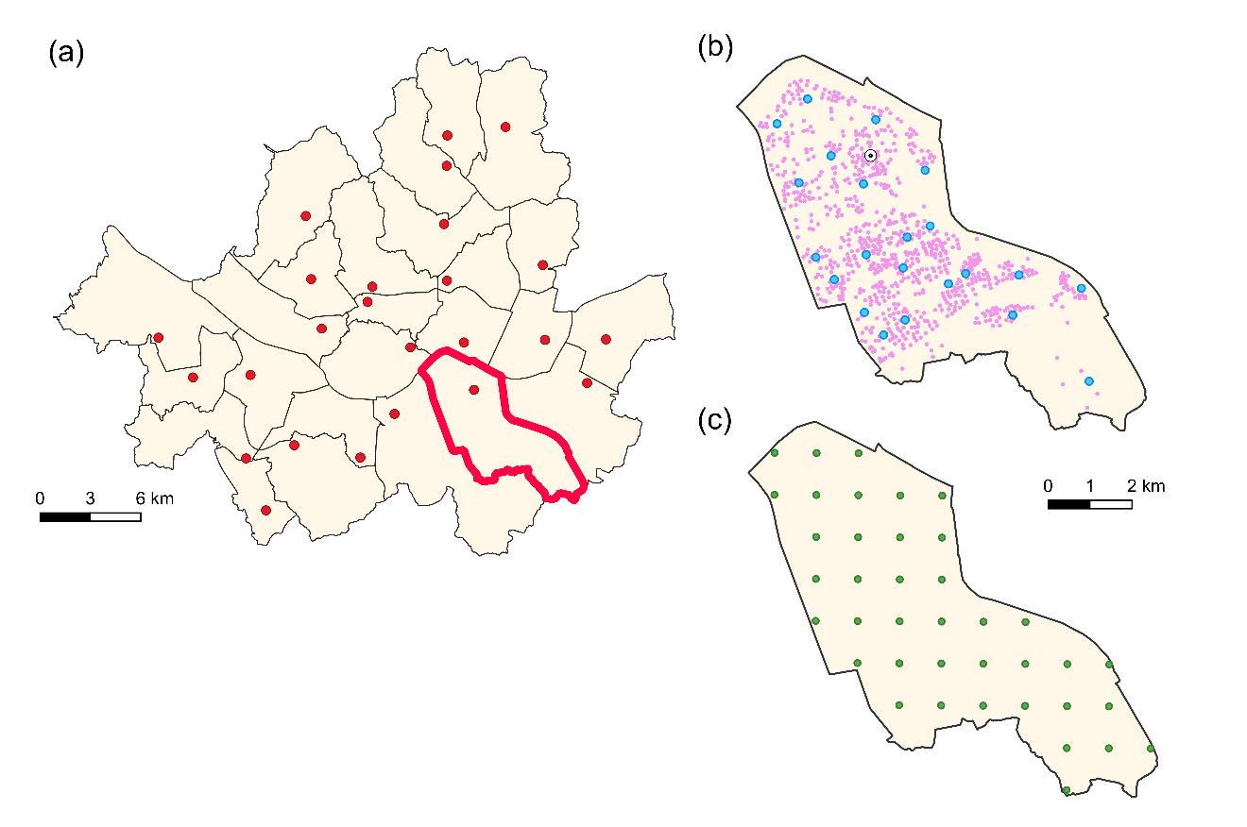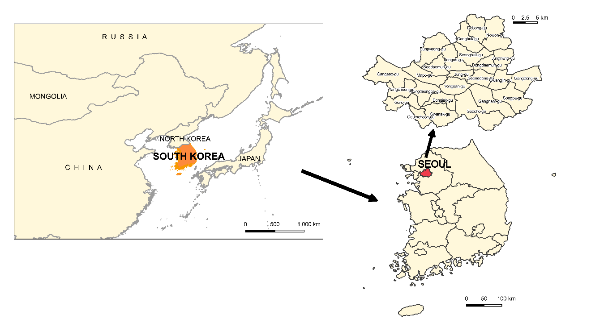**Figure S7.**

**Table S1.** Description of Data Availability Conditions (DAC1-DAC3) for individual-level PM10 concentrations and home addresses of 549,270 mothers residing in Seoul, Korea.

|  |  |  |
| --- | --- | --- |
| Data Availability Condition | PM10 concentration | Home address |
| DAC1 | All mothers | All mothers |
| DAC2 | Regulatory monitoring sites | All mothers |
| DAC3 | Regulatory monitoring sites | Limited to some coarse  district level |

**Table S2.** Mean and standard deviation of true and predicted PM10 annual average concentrations at 46,007 home addresses of mothers under three data availability scenarios (DAC1-DAC3), eight environmental scenarios (ES1-ES8), and six exposure prediction methods (UK, AA, UKD, UKNA, UKCA, and UKGA) at the 1st simulation

|  |  |  |  |  |  |  |  |
| --- | --- | --- | --- | --- | --- | --- | --- |
|  | DAC1 | DAC2 | DAC3 | | | | |
| Prediction methodb | TE | UK | AA | UKD | UKNA | UKCA | UKGA |
| ES1 | 51.16(5.56)a | 52.27(1.56) | 51.59(4.24) | 51.63(4.53) | 51.61(4.24) | 51.6(4.27) | 51.49(3.97) |
| ES2 | 49.8(5.97) | 49.97(1.59) | 49.71(4.13) | 49.91(4.8) | 49.68(4.49) | 49.81(4.38) | 49.49(4.04) |
| ES3 | 58.55(6.45) | 60.52(3.43) | 59.56(4.56) | 59.66(4.46) | 59.45(4.63) | 59.60(4.09) | 59.21(4.02) |
| ES4 | 46.9(5.11) | 47.52(1.99) | 47.61(2.56) | 47.57(2.29) | 47.42(1.21) | 47.52(1.50) | 47.25(1.04) |
| ES5 | 50.91(5.26) | 51.51(4.30) | 51.46(4.16) | 51.51(4.33) | 51.26(2.65) | 51.41(4.07) | 51.19(2.13) |
| ES6 | 53.05(4.66) | 53.21(3.45) | 53.32(4.08) | 53.37(3.54) | 53.19(2.07) | 53.22(2.86) | 52.99(2.00) |
| ES7 | 51.61(5.81) | 51.97(5.09) | 51.89(4.43) | 51.42(5.33) | 51.22(2.48) | 51.24(4.16) | 51.28(2.98) |
| ES8 | 51.19(5.17) | 51.35(4.32) | 51.97(4.29) | 51.34(4.64) | 51.21(1.74) | 51.19(3.14) | 51.13(2.41) |

a Mean (Standard deviation)

b TE: true-exposure; NM: nearest-monitor; IDWA: inverse-distance-weighted-average; LUR: land use regression; UK: universal kriging; AA: area-average UKD: UK prediction at a SGG district centroid; UKNA: district average based on UK predictions at neighbourhood centroids; UKCA: district average based on UK predictions at census tract centroids; UKGA: district average based on UK predictions at 1km-by-1km grid centroids

**Table S3.** Properties of effect estimates of true and predicted PM10 annual average concentrations on low birth weight over 1,000 simulations by three data availability conditions (DAC1-DAC3), five exposure prediction methods (AA, NM, IDWA, LUR, UK), and four environmental scenarios without mean structures (ES1-ES4)

|  |  |  |  |  |  |  |  |  |  |  |
| --- | --- | --- | --- | --- | --- | --- | --- | --- | --- | --- |
|  | | PM10 coefficient () | | | |  | PM10 coefficient () | | | |
| Biasa | RMSEb | ASEc | CPd |  | Biasa | RMSEb | ASEc | CPd |
|  | ES1 |  |  |  |  | ES2 |  |  |  |  |
| DAC1 | TE | 0.01 | 0.015 | 0.008 | 0.96 | TE | -0.04 | 0.015 | 0.008 | 0.95 |
| DAC2 | NM  IDWA  LUR  UK | -0.11  0.05  -0.20  -0.06 | 0.016  0.025  0.043  0.022 | 0.008  0.013  0.027  0.012 | 0.96  0.96  0.94  0.96 | NM  IDWA  LUR  UK | -0.13  -0.03  -0.33  -0.03 | 0.015  0.025  0.045  0.024 | 0.008  0.013  0.025  0.015 | 0.93  0.95  0.96  0.94 |
| DAC3 | AA  UKD  UKNA  UKCA  UKGA | -0.12  -0.08  0.05  -0.03  0.08 | 0.016  0.022  0.027  0.025  0.032 | 0.008  0.012  0.015  0.014  0.018 | 0.95  0.95  0.96  0.96  0.96 | AA  UKD  UKNA  UKCA  UKGA | -0.15  -0.08  -0.01  0.00  0.09 | 0.015  0.024  0.033  0.028  0.038 | 0.008  0.014  0.019  0.017  0.024 | 0.94  0.94  0.94  0.94  0.94 |
|  | ES3 |  |  |  |  | ES4 |  |  |  |  |
| DAC1 | TE | 0.03 | 0.015 | 0.008 | 0.95 | TE | -0.02 | 0.014 | 0.007 | 0.95 |
| DAC2 | NM  IDWA  LUR  UK | -0.16  -0.05  -0.09  -0.05 | 0.015  0.025  0.047  0.027 | 0.008  0.013  0.026  0.016 | 0.94  0.95  0.96  0.94 | NM  IDWA  LUR  UK | -0.30  -0.25  -0.37  -0.30 | 0.015  0.026  0.045  0.035 | 0.008  0.014  0.027  0.021 | 0.92  0.96  0.93  0.94 |
| DAC3 | AA  UKD  UKNA  UKCA  UKGA | -0.14  -0.09  0.07  0.05  0.04 | 0.016  0.027  0.041  0.033  0.048 | 0.008  0.016  0.027  0.020  0.036 | 0.95  0.94  0.94  0.95  0.94 | AA  UKD  UKNA  UKCA  UKGA | -0.29  -0.19  -0.23  -0.30  -0.17 | 0.015  0.036  0.065  0.045  0.079 | 0.008  0.019  0.038  0.030  0.045 | 0.94  0.96  0.94  0.92  0.95 |

a sample average of the bias (estimated beta – true beta) multiplied by 100

b root mean square of beta residuals

c average of standard error of estimated betas over simulations

d coverage probability with 95% confidence interval

**Table S4.** Properties of effect estimates of true and predicted PM10 annual average concentrations on low birth weight over 1,000 simulations by three data availability conditions (DAC1-DAC3), five exposure prediction methods (AA, NM, IDWA, LUR, UK), and four environmental scenarios with mean structures (ES5-ES8)

|  |  |  |  |  |  |  |  |  |  |  |
| --- | --- | --- | --- | --- | --- | --- | --- | --- | --- | --- |
|  | | PM10 coefficient () | | | |  | PM10 coefficient () | | | |
| Biasa | RMSEb | ASEc | CPd |  | Biasa | RMSEb | ASEc | CPd |
|  | ES5 |  |  |  |  | ES6 |  |  |  |  |
| DAC1 | TE | 0.03 | 0.015 | 0.008 | 0.95 | TE | 0.01 | 0.015 | 0.007 | 0.95 |
| DAC2 | NM  IDWA  LUR  UK | -0.16  0.00  -0.03  0.01 | 0.015  0.031  0.024  0.021 | 0.008  0.016  0.013  0.011 | 0.96  0.95  0.95  0.95 | NM  IDWA  LUR  UK | -0.20  -0.11  -0.04  -0.02 | 0.015  0.030  0.025  0.021 | 0.008  0.015  0.013  0.011 | 0.95  0.95  0.95  0.96 |
| DAC3 | AA  UKD  UKNA  UKCA  UKGA | -0.19  -0.16  0.04  0.01  0.05 | 0.018  0.020  0.031  0.023  0.037 | 0.009  0.011  0.017  0.013  0.020 | 0.95  0.94  0.94  0.94  0.95 | AA  UKD  UKNA  UKCA  UKGA | -0.24  -0.19  0.01  0.00  0.03 | 0.018  0.021  0.032  0.024  0.038 | 0.009  0.011  0.018  0.012  0.021 | 0.96  0.95  0.95  0.95  0.95 |
|  | ES7 |  |  |  |  | ES8 |  |  |  |  |
| DAC1 | TE | -0.01 | 0.014 | 0.007 | 0.95 | TE | 0.00 | 0.014 | 0.007 | 0.95 |
| DAC2 | NM  IDWA  LUR  UK | -0.28  -0.23  0.01  0.00 | 0.015  0.036  0.018  0.017 | 0.008  0.019  0.009  0.009 | 0.94  0.94  0.94  0.93 | NM  IDWA  LUR  UK | -0.29  -0.21  -0.01  -0.01 | 0.015  0.037  0.018  0.017 | 0.008  0.019  0.009  0.009 | 0.94  0.94  0.96  0.96 |
| DAC3 | AA  UKD  UKNA  UKCA  UKGA | -0.31  -0.24  0.08  0.02  0.01 | 0.020  0.019  0.039  0.022  0.032 | 0.010  0.010  0.021  0.012  0.017 | 0.94  0.94  0.94  0.94  0.95 | AA  UKD  UKNA  UKCA  UKGA | -0.25  -0.24  0.06  0.02  -0.11 | 0.020  0.019  0.041  0.022  0.033 | 0.010  0.010  0.021  0.012  0.017 | 0.95  0.95  0.94  0.96  0.95 |

a sample average of the bias (estimated beta – true beta) multiplied by 100

b root mean square of beta residuals

c average of standard error of estimated betas over simulations

d coverage probability with 95% confidence interval

**Table S5.** Summaries of linear regression fitting for 8 environmental scenarios with 8 exposure modelling strategies

|  |  |  |  |  |  |  |  |  |  |  |  |  |
| --- | --- | --- | --- | --- | --- | --- | --- | --- | --- | --- | --- | --- |
| PLAIN | ES1 | | | ES2 | | | ES3 | | | ES4 | | |
|  | R | Inter | Slope | R | Inter | Slope | R | Inter | Slope | R | Inter | Slope | |
| DAC2 |  |  |  |  |  |  |  |  |  |  |  |  | |
| NM | 0.623 | 11.692 | 0.776 | 0.488 | 19.517 | 0.609 | 0.517 | 20.833 | 0.657 | 0.036 | 40.796 | 0.141 | |
| IDWA | 0.618 | 21.01 | 0.589 | 0.502 | 27.461 | 0.452 | 0.606 | 24.773 | 0.589 | 0.072 | 40.82 | 0.142 | |
| LUR | 0.019 | 50.282 | 0.039 | 0.025 | 47.871 | 0.042 | 0.016 | 64.503 | -0.068 | 0.031 | 50.734 | -0.069 | |
| UK | 0.697 | 16.783 | 0.681 | 0.467 | 22.562 | 0.549 | 0.456 | 32.29 | 0.467 | 0.001 | 48.26 | -0.015 | |
| DAC3 |  |  |  |  |  |  |  |  |  |  |  |  | |
| AA | 0.503 | 13.507 | 0.732 | 0.419 | 20.913 | 0.579 | 0.468 | 19.183 | 0.684 | 0.032 | 40.099 | 0.161 | |
| UKD | 0.524 | 23.326 | 0.552 | 0.49 | 25.546 | 0.485 | 0.502 | 30.255 | 0.501 | 0.001 | 46.73 | 0.019 | |
| UKNA | 0.637 | 20.471 | 0.609 | 0.452 | 24.458 | 0.506 | 0.585 | 27.297 | 0.549 | 0.006 | 46.57 | 0.018 | |
| UKCA | 0.639 | 20.15 | 0.615 | 0.473 | 24.701 | 0.504 | 0.465 | 34.3 | 0.432 | 0.003 | 48.226 | -0.015 | |
| UKGA | 0.603 | 23.141 | 0.554 | 0.444 | 27.052 | 0.451 | 0.55 | 32.109 | 0.463 | 0.017 | 46.009 | 0.026 | |
| NON-PLAIN | ES5 | | | ES6 | | | ES7 | | | ES8 | | |
|  | R | Inter | Slope | R | Inter | Slope | R | Inter | Slope | R | Inter | Slope | |
| DAC2 |  |  |  |  |  |  |  |  |  |  |  |  | |
| NM | 0.296 | 22.392 | 0.552 | 0.176 | 30.837 | 0.422 | 0.130 | 34.920 | 0.302 | 0.031 | 42.520 | 0.156 | |
| IDWA | 0.207 | 39.608 | 0.204 | 0.131 | 41.867 | 0.204 | 0.136 | 43.303 | 0.120 | 0.005 | 48.076 | 0.028 | |
| LUR | 0.359 | 26.58 | 0.490 | 0.266 | 32.955 | 0.382 | 0.648 | 15.567 | 0.705 | 0.603 | 18.113 | 0.649 | |
| UK | 0.371 | 25.985 | 0.501 | 0.381 | 28.44 | 0.47 | 0.668 | 12.658 | 0.751 | 0.587 | 16.053 | 0.689 | |
| DAC3 |  |  |  |  |  |  |  |  |  |  |  |  | |
| AA | 0.088 | 37.862 | 0.236 | 0.035 | 43.304 | 0.183 | 0.070 | 41.073 | 0.160 | 0.000 | 49.132 | 0.010 | |
| UKD | 0.096 | 38.949 | 0.246 | 0.079 | 40.238 | 0.247 | 0.071 | 41.414 | 0.203 | 0.011 | 47.427 | 0.089 | |
| UKNA | 0.219 | 39.225 | 0.236 | 0.189 | 42.954 | 0.193 | 0.287 | 39.422 | 0.229 | 0.169 | 44.122 | 0.138 | |
| UKCA | 0.361 | 27.731 | 0.465 | 0.258 | 36.678 | 0.312 | 0.428 | 27.085 | 0.468 | 0.395 | 31.623 | 0.382 | |
| UKGA | 0.153 | 43.120 | 0.158 | 0.164 | 43.785 | 0.173 | 0.268 | 37.59 | 0.265 | 0.143 | 42.129 | 0.176 | |

**Table S6.** Mean and standard deviation of true and predicted PM10 annual average concentrations at 46,007 home addresses of mothers under three data availability scenarios (DAC1-DAC3), eight environmental scenarios (ES1-ES8), and eight exposure prediction methods (AA, NM, IDWA, LUR, UK, UKD, UKNA, UKCA, and UKGA) at the 1st simulation

|  |  |  |  |  |  |  |  |  |  |  |
| --- | --- | --- | --- | --- | --- | --- | --- | --- | --- | --- |
|  | DAC1 | DAC2 | | | | DAC3 | | | | |
|  | TEb | NMb | IDWAb | LURb | UKb | AAb | UKDb | UKNAb | UKCAb | UKGAb |
| ES1 | 51.16(5.56) a | 50.94(5.73) | 51.42(5.47) | 51.14(4.16) | 52.27(1.56) | 51.59(4.24) | 51.63(4.53) | 51.61(4.24) | 51.6(4.27) | 51.49(3.97) |
| ES2 | 49.8(5.97) | 49.75(5.34) | 49.83(5.2) | 49.94(3.8) | 49.97(1.59) | 49.71(4.13) | 49.91(4.8) | 49.68(4.49) | 49.81(4.38) | 49.49(4.04) |
| ES3 | 58.55(6.45) | 59.23(6.45) | 59.27(5.89) | 59.27(4.88) | 60.52(3.43) | 59.56(4.56) | 59.66(4.46) | 59.45(4.63) | 59.6(4.09) | 59.21(4.02) |
| ES4 | 46.9(5.11) | 47.68(4.59) | 47.43(3.81) | 47.48(2.71) | 47.52(1.99) | 47.61(2.56) | 47.57(2.29) | 47.42(1.21) | 47.52(1.5) | 47.25(1.04) |
| ES5 | 50.91(5.26) | 49.87(4.18) | 50.47(5.33) | 49.98(2.35) | 51.51(4.30) | 51.46(4.16) | 51.51(4.33) | 51.26(2.65) | 51.41(4.07) | 51.19(2.13) |
| ES6 | 53.05(4.66) | 53.02(4.57) | 53.22(4.68) | 52.67(2.62) | 53.21(3.45) | 53.32(4.08) | 53.37(3.54) | 53.19(2.07) | 53.22(2.86) | 52.99(2.00) |
| ES7 | 51.61(5.81) | 49.34(3.51) | 50.51(4.86) | 49.49(1.89) | 51.97(5.09) | 51.89(4.43) | 51.42(5.33) | 51.22(2.48) | 51.24(4.16) | 51.28(2.98) |
| ES8 | 51.19(5.17) | 49.66(4.00) | 50.53(4.58) | 49.53(2.03) | 51.35(4.32) | 51.97(4.29) | 51.34(4.64) | 51.21(1.74) | 51.19(3.14) | 51.13(2.41) |

a Mean (Standard deviation)

b TE: true-exposure; NM: nearest-monitor; IDWA: inverse-distance-weighted-average; LUR: land use regression; UK: universal kriging; AA: area-average UKGA: UK prediction at a SGG district centroid; UKNA: district average based on UK predictions at neighbourhood centroids; UKCA: district average based on UK predictions at census tract centroids